|  |  |
| --- | --- |
| revision | B1.0 |

DTY PU Life Monitor (Filament)

User’s Manual

**Prepared By**

NANYA PLASTICS CORP., AMERICA

LAKE CITY, SC 29560

USA

**Programmer**

Chiu Loung Huang

**Date**

10/12/2021

# Revision Control

|  |  |  |
| --- | --- | --- |
| **Number** | **Date** | **Description** |
| 1.0 | 2021-10-12 | Document Created |
| 2.0 |  |  |
| 3.0 |  |  |
| 4.0 |  |  |

**Contents**

Revision Control 2

1. Descritpion 4
2. System Overview 4
3. SQL Database 5

**3.1** **DTY Daily Production** 5

**3.2** **DTY Condition Historty (Barmag)** 5

**3.3** **DTY Condition Historty (TMT)** 6

**3.4 DTY Current Running Conditions (Barmag)**  6

**3.5 DTY Current Running Conditions (TMT)** 7

1. Software Requirements 8
2. User Interface

**5.1** **PU Set Overview** 9

**5.2** **Current Set History** 10

**5.3** **All Time Historical Data** 11

1. Publishing Program 12
2. Installing Program 13
3. **Description.**

For the better management purpose, the DTY PU Life Monitor is a supplement to the “DTY Condition Card Program”.

* 1. Provides better overview of all PU Set being used in production on all machines and not used (online/Offline PU SET).
  2. Prevents using the wrong PU Set when supervisor/manager issues condition cards.
  3. Prevents using PU Set that exceeds the PU Set Life limit by providing historical information of current PU set utilization span.
  4. Help DTY Section to maximize utilization of each PU Set while still keeping consistent yarn quality.

1. **System Overview**

**PU Life program combines data from 2 databases (2 programs previously developed) in Nan Ya Lake City SQL data server (172.16.216.7):**

**Process Report Database: [172.16.216.7].[ProcReport]**

**Production Condition Card: [172.16.216.7].[StapleReport]**

2.1 Process Report Database: this is DTY Production Status Database which has data for Production Information such as M/C, Spec, POY Lot, Maintenance Date…etc

2.2 DTY Production Condition Card: this is the Database which has conditions data for the PU SET, Stack configuration, Hardness for each lot.



1. **SQL Server Database (Sql 2000 and above):**

**3.1 DTY Daily Production**

## Table – [172.16.216.7].[ProcReport].[DBO].[DTYDetail]

|  |  |  |  |
| --- | --- | --- | --- |
| **Order** | **Field Name** | **Type** | **Description** |
| 1 | dt_pdate | varchar(10) | DTY Production Date |
| 2 | dt_mac | varchar(5) | DTY Machine No. |
| 3 | dt_lotno | varchar(10) | DTY Lot No. |
| 4 | dt_spec | varchar(10) | DTY Production Spec |
| 5 | dt_sm | varchar(5) | Special Mark |
| 6 | dt_ply | Int | Ply |
| 7 | dt_poylot | varchar(10) | Used POY Lot |
| 8 | dt_poysm | varchar(5) | POY Lot Special Mark |
| 9 | dt_poyoil | varchar(15) | POY Oil Name |
| 10 | dt_mtdate | Datetime | Last date of Maintenance of the machine |
| 11 | dt_TotalBobins | int | Total Bobbins produced in a day |

**3.2 DTY Condition History for Barmag Machines**

## Table – [172.16.216.7].[StapleReport].[DBO].[DTY_Cond_Hist]

|  |  |  |  |
| --- | --- | --- | --- |
| **Order** | **Field Name** | **Type** | **Description** |
| 1 | Create_pDate | varchar(10) | Condition Creation date |
| 2 | MC_No | varchar(50) | DTY Machine No. |
| 3 | DTY_LotNo | varchar(50) | DTY Lot No |
| 4 | PU_Type | varchar(50) | PU Type: 9 mm |
| 5 | PU_Diameter | varchar(50) | 53.5mm |
| 6 | PU_hardness | varchar(50) | PU Hardness: 87A, 85A, 88A |
| 7 | PU_Stack | varchar(50) | Disc configuration: 1-4-1 S/Z/SZ, 1-5-1 S/Z/SZ |
| 8 | PU_SetNo | varchar(50) | Barmag M/C Set A ~ R (18 Sets); |
| 9 | PU_Assemble_Date | varchar(50) | Date the PU set was assembled |
| 10 | dUserName | varchar(50) | Creator of the Condition |

**3.3 DTY Condition History for TMT Machines**

## Table – [172.16.216.7].[StapleReport].[DBO].[DTY_TMTCond_Hist_New]

|  |  |  |  |
| --- | --- | --- | --- |
| **Order** | **Field Name** | **Type** | **Description** |
| 1 | Create_pDate | varchar(10) | Condition Creation date |
| 2 | MC_No | varchar(50) | DTY Machine No. |
| 3 | DTY_LotNo | varchar(50) | DTY Lot No |
| 4 | PU_Type | varchar(50) | PU Type: 9 mm |
| 5 | PU_Diameter | varchar(50) | 58mm |
| 6 | PU_hardness | varchar(50) | PU Hardness: 87A, 85A, 88A |
| 7 | PU_Stack | varchar(50) | Disc configuration: 1-4-1 S/Z/SZ, 1-5-1 S/Z/SZ |
| 8 | PU_SetNo | varchar(50) | TMT M/C: SET S~U (3 sets) |
| 9 | PU_Assemble_Date | varchar(50) | Date the PU set was assembled |
| 10 | dUserName | varchar(50) | Creator of the Condition |

**3.4 Current Running DTY Production Conditions (Barmag Machines)**

Table **– [172.16.216.7].[StapleReport].[DBO].[DTY_Cond_Now]**

|  |  |  |  |
| --- | --- | --- | --- |
| **Order** | **Field Name** | **Type** | **Description** |
| 1 | Dty_pdate | varchar(12) | Production Start Date of the Lot |
| 2 | MC_No | varchar(50) | DTY Machine |
| 3 | DTY_LotNo | varchar(50) | DTY lot No |
| 4 | PU_Type | varchar(50) | PU Type: 9 mm |
| 5 | PU_Diameter | varchar(50) | PU Diameter 53.5 mm |
| 6 | PU_hardness | varchar(50) | 85A, 86A, 87A |
| 7 | PU_Stack | varchar(50) | Disc configuration: 1-4-1 S/Z/SZ, 1-5-1 S/Z/SZ |
| 8 | PU_SetNo | varchar(50) | Barmag M/C Set A ~ R (18 Sets); |
| 9 | PU_Assemble_Date | varchar(50) | Date the PU set was assembled |
| 10 |  |  |  |
| 11 |  |  |  |

**3.5 Current Running DTY Production Conditions (TMT Machines)**

Table **– [172.16.216.7].[StapleReport].[DBO].[DTY_TMT_CondNow_New]**

|  |  |  |  |
| --- | --- | --- | --- |
| **Order** | **Field Name** | **Type** | **Description** |
| 1 | Dty_pdate | varchar(12) | Production Start Date of the Lot |
| 2 | MC_No | varchar(50) | DTY Machine |
| 3 | DTY_LotNo | varchar(50) | DTY lot No |
| 4 | PU_Type | varchar(50) | PU Type: 9 mm |
| 5 | PU_Diameter | varchar(50) | PU Diameter 53.5 mm |
| 6 | PU_hardness | varchar(50) | 85A, 86A, 87A |
| 7 | PU_Stack | varchar(50) | Disc configuration: 1-4-1 S/Z/SZ, 1-5-1 S/Z/SZ |
| 8 | PU_SetNo | varchar(50) | TMT M/C: SET S~U (3 sets) |
| 9 | PU_Assemble_Date | varchar(50) | Date the PU set was assembled |
| 10 |  |  |  |
| 11 |  |  |  |

1. **Software Requirements**
   1. **Developer Environment (IDE)**

**Microsoft Visual Studio Community 2017 (Free)**

<https://visualstudio.microsoft.com/vs/older-downloads/>

* 1. **Microsoft .NET Framework 3.5 + (Free)**

<https://www.microsoft.com/en-us/download/details.aspx?id=21>

* 1. **Graphical UI**

**DevExpress Winform 12.2 Libraries (.DLL)**

* **Devexpress.Charts.v12.2.Core**
* **Devexpress.Data.v12.2**
* **Devexpress.Utils.v12.2**
* **Devexpress.XtraCharts.v12.2**
* **Devexpress.XtraCharts.v12.2.UI**
* **Devexpress.XtraEditors.v12.2**
* **Devexpress.XtraGrid.v12.2**

**One Developer perpetual license USD$999.99**

<https://www.devexpress.com/products/net/controls/winforms/>

1. **User Interface**
   1. PU SET Overview.

It is the overview of all 16 DTY Machines and the PU SET that is currently being used on any particular machine. If a machine is shut down, it will show N/A (Not Available).

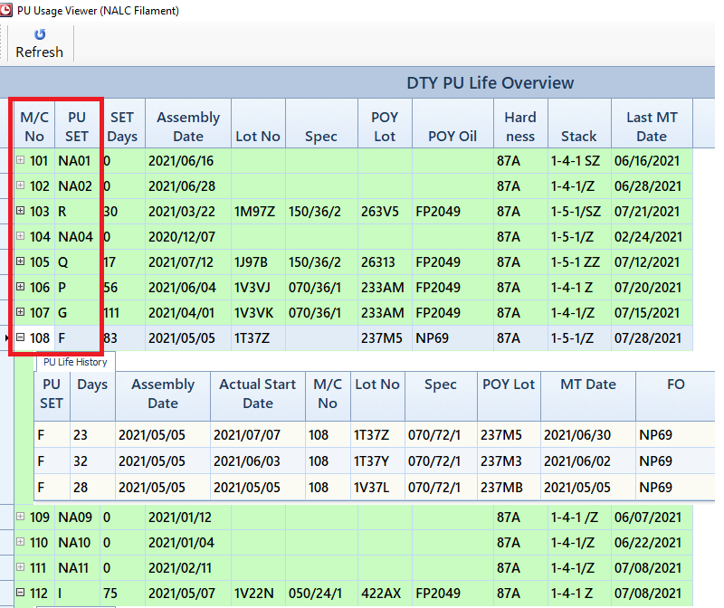

* 1. Current Set History.

By expanding the “+” in front of each Machine number, it will display the history of current set.

For example, “D” PU Set were used on M/C 102 for 21 days for DTY lot 1A6EK, then 22 day on the same M/C for lot 1A6EL, then currently 100 days on M/C 113 for lot 1J63A. Making it a total 143 days. 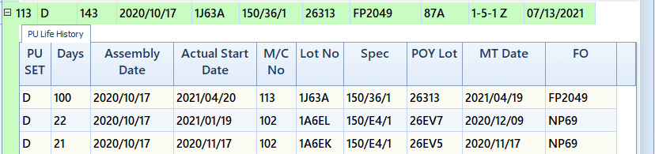

* 1. All Time Historical Data.

One can select a particular set from the Drop-Down box on the top right-hand corner, and it will search from the Production Condition database ALL the conditions that used that SET by “Assembly Date”.

Also a historical graph of USED DAYS will also be displayed for each PU Assembly. 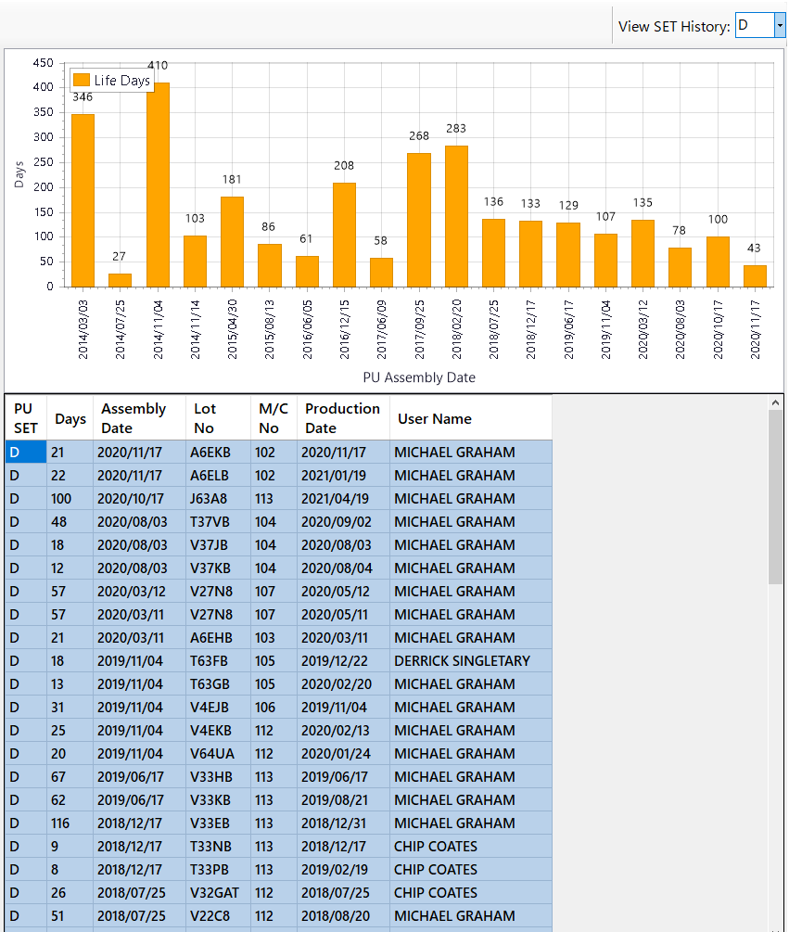

1. **Publishing Program**

When publishing the program, needs to make sure “Publish Status” is set to “Include” for the Devexpress DLL. This copies the libraries with the proper license to the user’s installing folder.

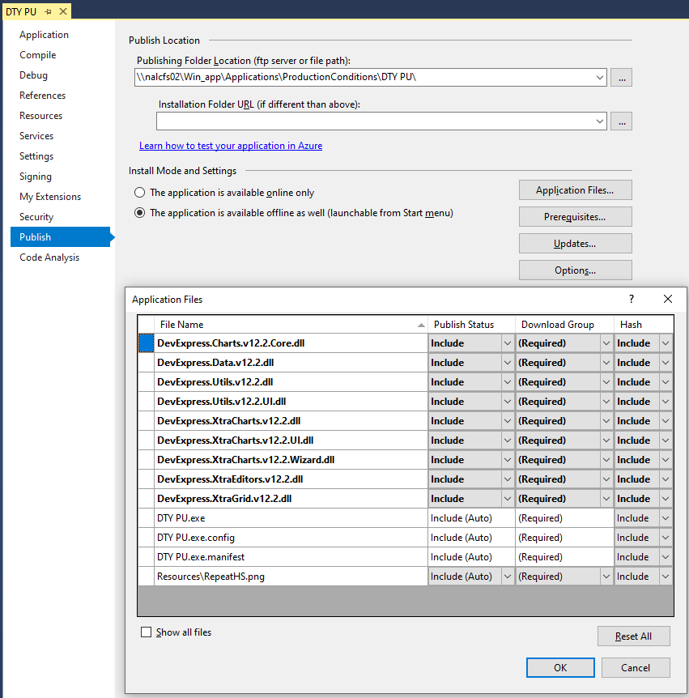

1. **Installing Program**

**Minimum System Requirement**

* 1. **Windows 7 & above 32-Bit or 64-bit**
  2. **At least 20GB HDD free space**
  3. **.NET Framework 3.5**
  4. **The install program is located at “\\..\..\DTY PU\setup.exe. Double click on setup.exe icon to install. Click Install Button to continue.**

